**Batch: B-3 Roll No.: 16010422234 Experiment No.: 1**

**______________________________________________________________________________**

**Output (code with result snapshot):-**

**Code:**

**<!DOCTYPE html>**

**<html>**

**<head>**

**<title>PHP Basic Constructs</title>**

**</head>**

**<body>**

**<h1>PHP Basic Constructs</h1>**

**<?php**

**$string = "Hello, PHP!";**

**$integer = 42;**

**$float = 3.14;**

**$boolean = true;**

**$array = array("Red", "Green", "Blue");**

**$null = NULL;**

**echo "<h2>Data Types</h2>";**

**echo "String: $string<br>";**

**echo "Integer: $integer<br>";**

**echo "Float: $float<br>";**

**echo "Boolean: " . ($boolean ? 'true' : 'false') . "<br>";**

**echo "Array: " . implode(", ", $array) . "<br>";**

**echo "NULL: " . var_export($null, true) . "<br>";**

**echo "<h2>Control Structures</h2>";**

**echo "<h3>if Statement</h3>";**

**$t = date("H");**

**if ($t < "12") {**

**echo "Good morning!<br>";**

**}**

**echo "<h3>if...else Statement</h3>";**

**if ($t < "12") {**

**echo "Good morning!<br>";**

**} else {**

**echo "Good afternoon!<br>";**

**}**

**echo "<h3>if...elseif...else Statement</h3>";**

**if ($t < "10") {**

**echo "Have a good morning!<br>";**

**} elseif ($t < "20") {**

**echo "Have a good day!<br>";**

**} else {**

**echo "Have a good night!<br>";**

**}**

**echo "<h3>switch Statement</h3>";**

**$favcolor = "red";**

**switch ($favcolor) {**

**case "red":**

**echo "Your favorite color is red!<br>";**

**break;**

**case "blue":**

**echo "Your favorite color is blue!<br>";**

**break;**

**case "green":**

**echo "Your favorite color is green!<br>";**

**break;**

**default:**

**echo "Your favorite color is neither red, blue, nor green!<br>";**

**}**

**echo "<h3>for Loop</h3>";**

**for ($x = 0; $x <= 5; $x++) {**

**echo "The number is: $x <br>";**

**}**

**echo "<h3>while Loop</h3>";**

**$x = 0;**

**while($x <= 5) {**

**echo "The number is: $x <br>";**

**$x++;**

**}**

**echo "<h3>do...while Loop</h3>";**

**$x = 0;**

**do {**

**echo "The number is: $x <br>";**

**$x++;**

**} while ($x <= 5);**

**echo "<h3>foreach Loop</h3>";**

**foreach ($array as $value) {**

**echo "Color: $value <br>";**

**}**

**echo "<h2>String Functions</h2>";**

**echo "Length of string 'Hello, PHP!': " . strlen($string) . "<br>";**

**echo "String to Upper Case: " . strtoupper($string) . "<br>";**

**echo "String to Lower Case: " . strtolower($string) . "<br>";**

**echo "Reverse String: " . strrev($string) . "<br>";**

**echo "<h2>Date and Time Functions</h2>";**

**echo "Current Date and Time: " . date("d-m-y H:i:s") . "<br>";**

**echo "Current Year: " . date("Y") . "<br>";**

**echo "Current Month: " . date("F") . "<br>";**

**echo "Current Day: " . date("l") . "<br>";**

**echo "<h2>Math Functions</h2>";**

**echo "Value of PI: " . pi() . "<br>";**

**echo "Absolute value of -3: " . abs(-3) . "<br>";**

**echo "Minimum of (1, 60, 104, 22, -2, -34): " . min(1, 60, 104, 22, -2, -34) . "<br>";**

**echo "Maximum of (1, 60, 104, 22, -2, -34): " . max(1, 60, 104, 22, -2, -34) . "<br>";**

**?>**

**</body>**

**</html>**

**Result:**

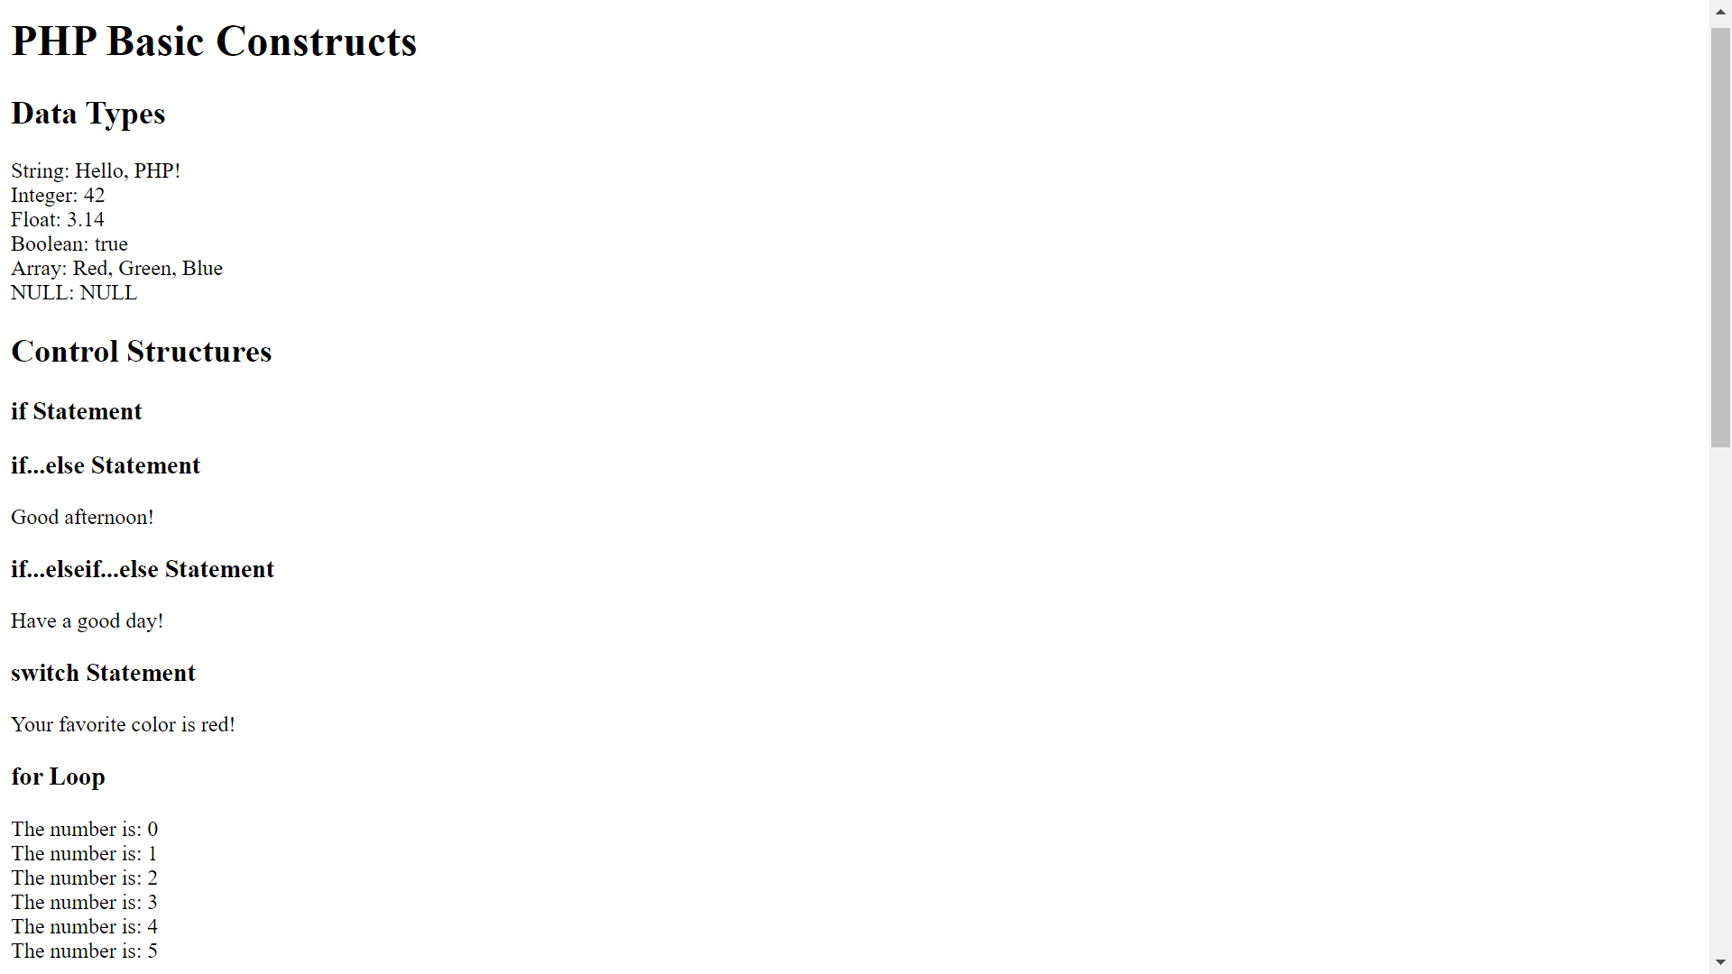

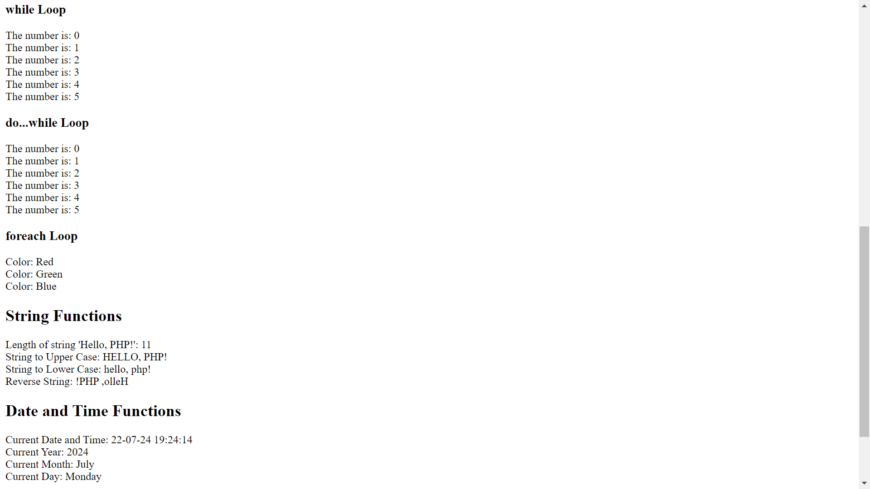

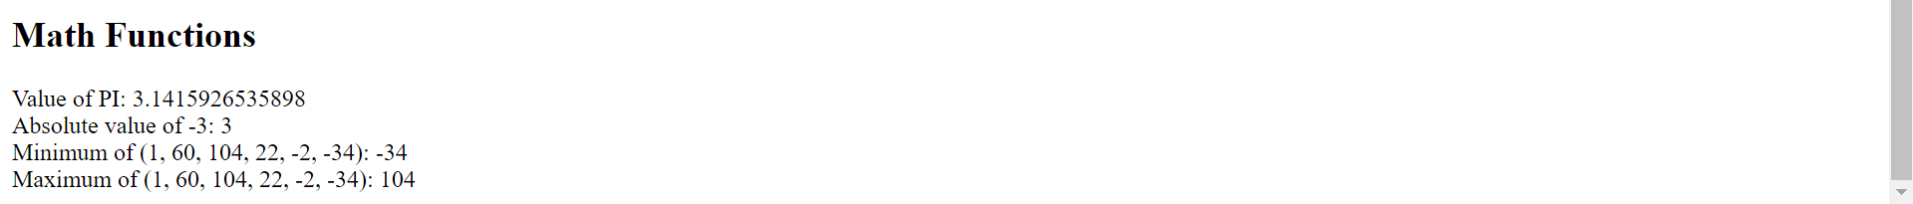

**______________________________________________________________________________**

**Post Lab Questions:-**

**1. Explain Loops in PHP with examples.**

**Ans:** Loops are used in programming to repeat a block of code as long as a specified condition is true. PHP supports four types of loops:

a. while Loop

The while loop executes a block of code as long as the specified condition is true.

Example:

$x = 1;

while($x <= 5) {

echo "The number is: $x <br>";

$x++;

}

This code will output the numbers from 1 to 5.

b. do...while Loop

The do...while loop will always execute the block of code once, then it will repeat the loop as long as the specified condition is true.

Example:

$x = 1;

do {

echo "The number is: $x <br>";

$x++;

} while ($x <= 5);

This code will also output the numbers from 1 to 5.

c. for Loop

The for loop is used when you know in advance how many times you want to execute a statement or a block of code.

Example:

for ($x = 0; $x <= 10; $x++) {

echo "The number is: $x <br>";

}

This code will output the numbers from 0 to 10.

d. foreach Loop

The foreach loop works only on arrays and is used to loop through each key/value pair in an array.

Example:

$colors = array("red", "green", "blue", "yellow");

foreach ($colors as $value) {

echo "$value <br>";

}

This code will output each color in the array.

**2. Why choose PHP over other programming languages?**

**Ans:** There are several reasons why PHP is chosen over other programming languages, especially for web development:

a. Ease of Use

PHP is relatively easy to learn compared to other programming languages. Its syntax is similar to C and Java, making it easier for developers with experience in those languages to pick up PHP quickly.

b. Wide Adoption and Community Support

PHP has been around for a long time and is widely used. This has resulted in a large community of developers who contribute to a vast repository of documentation, tutorials, and forums. This makes it easier to find solutions to common problems and get support when needed.

c. Compatibility

PHP is compatible with almost all servers used today (Apache, IIS, etc.) and works well with a variety of databases (MySQL, PostgreSQL, Oracle, etc.). This makes it a versatile choice for web development.

d. Cost-Effective

PHP is open-source and free to use. This significantly reduces the cost of development and deployment, especially for small businesses and individual developers.

e. Performance

PHP scripts execute on the server side. It is known for its speed and efficiency, especially when running on the LAMP stack (Linux, Apache, MySQL, PHP).

f. Frameworks and Tools

PHP has a variety of frameworks (like Laravel, Symfony, CodeIgniter) that streamline and enhance development processes. These frameworks provide a structured way to build web applications quickly and efficiently.

g. Flexibility

PHP allows developers to make changes in the code easily and quickly, making it ideal for dynamic websites where content changes frequently.

h. Integration Capabilities

PHP can easily be integrated with other technologies, including HTML, CSS, JavaScript, and various databases. It also supports integration with web services and APIs.

i. Security

While PHP has had some security issues in the past, the language and its frameworks have evolved to incorporate robust security features. Additionally, there are many best practices and tools available to secure PHP applications.

**______________________________________________________________________________**

**Outcomes: Illustrate use of basic PHP concepts to develop applications**

**______________________________________________________________________________**

**Conclusion:-**

The experiment aimed to demonstrate the use of basic PHP programming constructs such as data types, string functions, date and time functions, and math functions. The objectives were successfully achieved by implementing and executing the PHP code that showcased these constructs. The output matched the expected results, confirming the correct understanding and application of PHP basics.

**______________________________________________________________________________**